Adam Mohmoud
AZ-900 Fundamentals
Create a SQL Database Lab
Mohmoud.adam@gmail.com

In this lab, I will create a SQL database in Azure involves provisioning a managed relational database service, offering features like scalability, security, and automated backups, to store and manage structured data for your applications.
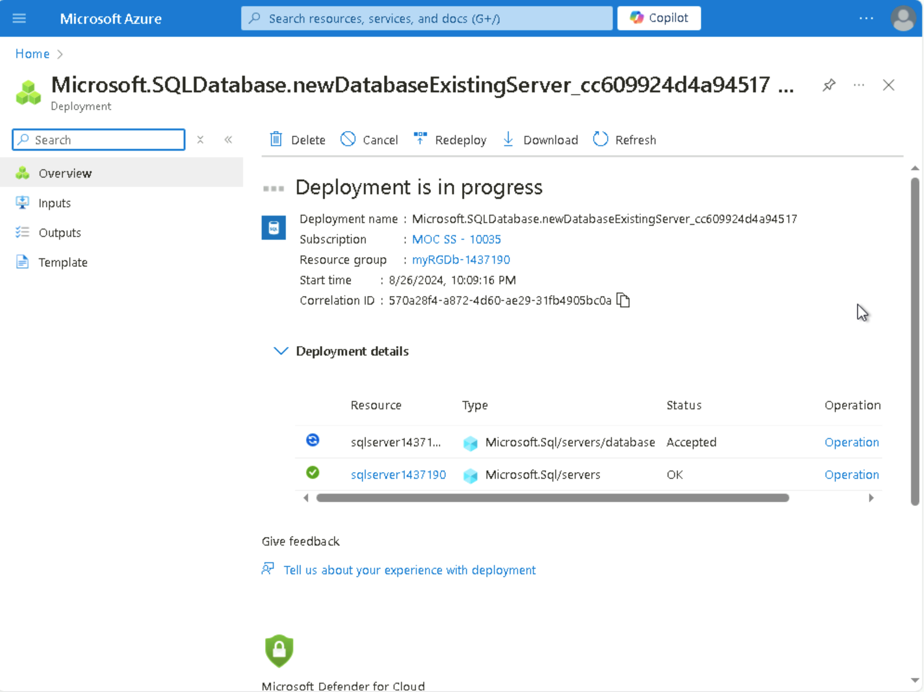

I am going to choose ‘Create SQL Database’ and enter the project information and create a database name and server for this lab.
After the deployment is successful, I configure SQL server and run a SQL query.
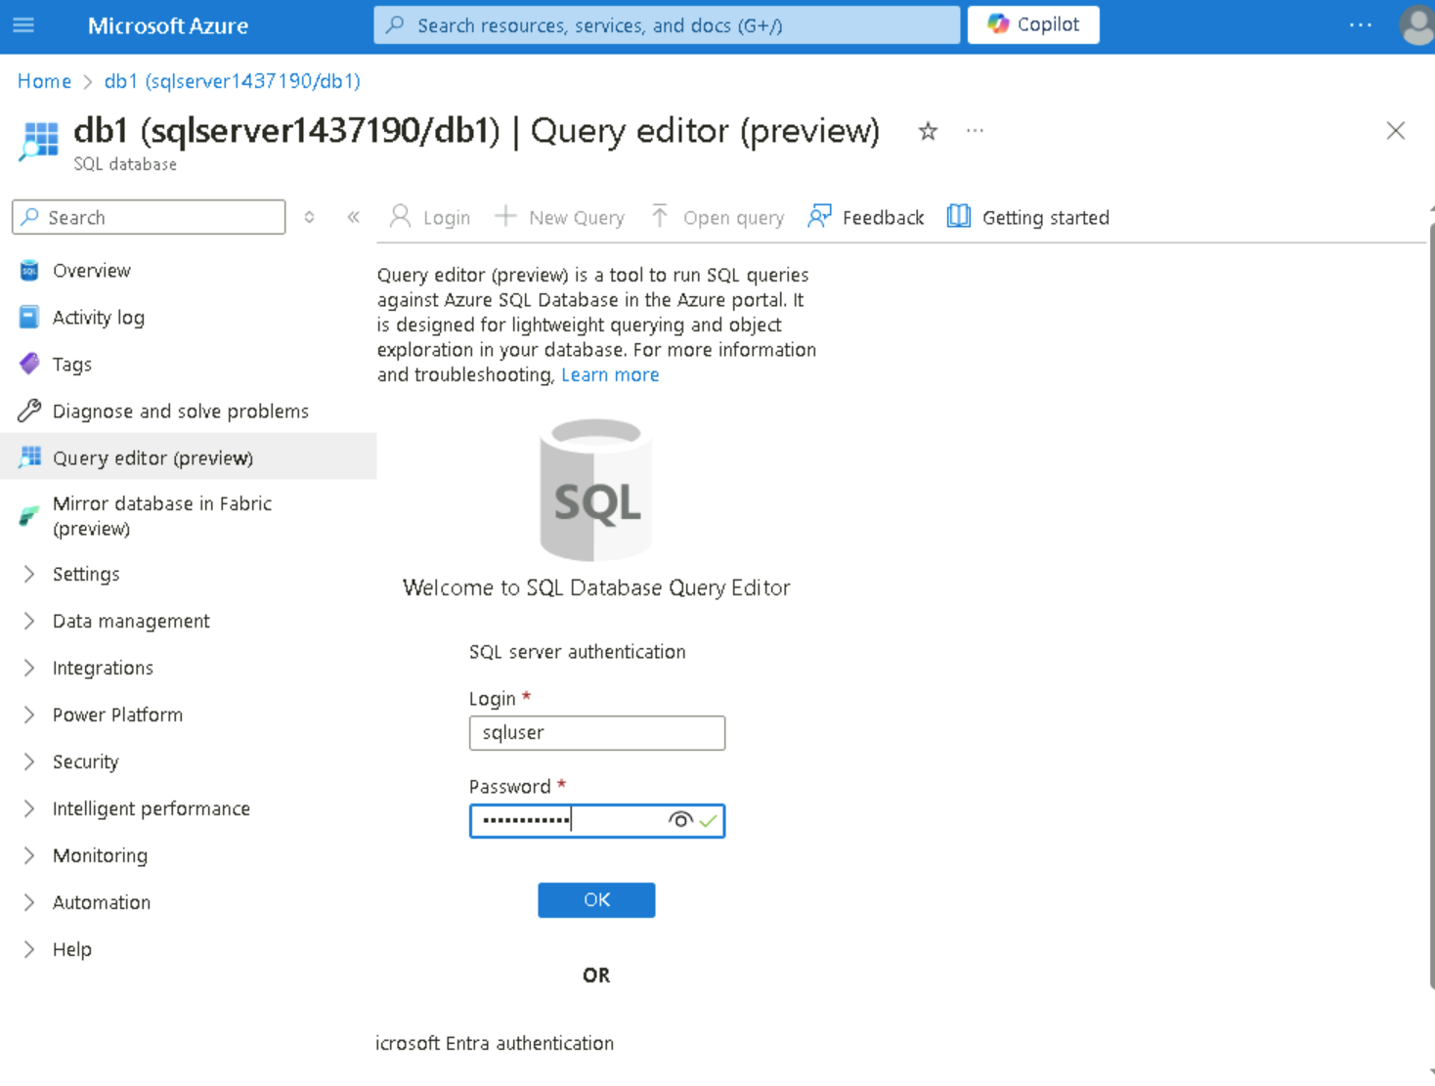

Once you log in successfully the query pane appears, enter the following query into the editor pane:
SELECT TOP 20 pc.Name as CategoryName, p.name as ProductName
FROM SalesLT.ProductCategory pc
JOIN SalesLT.Product p
ON pc.productcategoryid = p.productcategoryid;
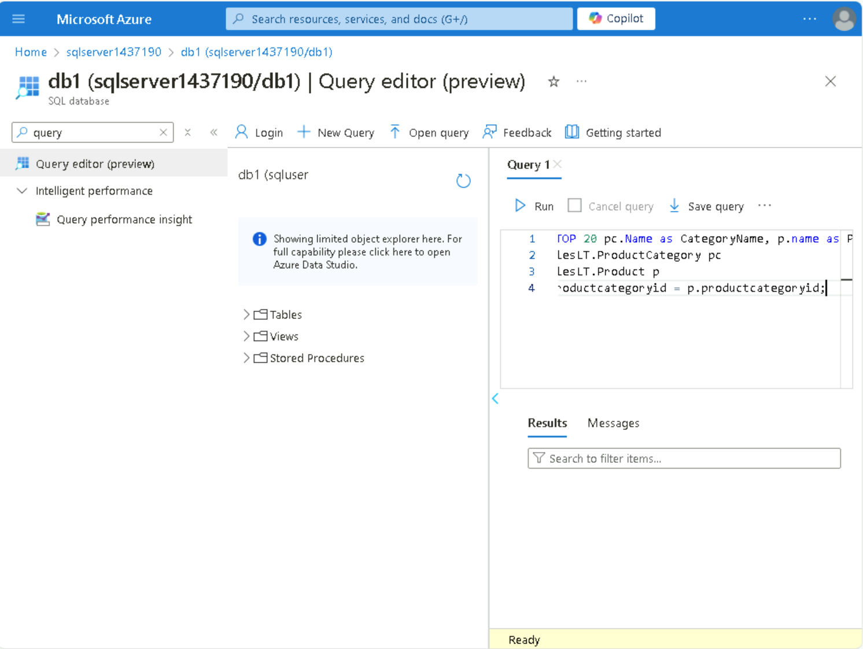
This SQL query selects the top 20 records from the SalesLT.ProductCategory table and SalesLT.Product table, displaying the CategoryName from the ProductCategory table as "CategoryName" and the ProductName from the Product table as "ProductName." The query performs an inner join between the two tables based on the productcategoryid column.
I will proceed to run the query.
